

11 November 2008
[19-08]

DRAFT ASSESSMENT

APPLICATION A588

VOLUNTARY ADDITION OF FLUORIDE TO PACKAGED WATER

SUPPORTING DOCUMENT 4

DERIVATION OF THE UPPER LEVEL
FOR FLUORIDE INTAKE

Attachment SD4

Derivation of the Upper Level for Fluoride Intake

Background

The fluoride dietary intake assessment for 2-8 year old Australian children described in detail in Supporting Document 3 and the Risk Assessment, indicated that the current UL may be assigned at a level that is not representative of actual fluoride intakes. Therefore, FSANZ examined the derivation of the UL to understand the basis of the reference value, particularly in relation to infants and children up to 8 years, and establish whether this exceedance was a cause for concern.

Upper Level for Fluoride Intake

The cariostatic effect of fluoride is the primary reason for fortifying reticulated drinking water with fluoride ions. This relationship, and coincident dental enamel fluorosis, is illustrated in Figure 1. It is well established that dental fluorosis is caused by excessive fluoride intake in infants and children during the pre-eruptive phase of tooth development. A more serious form which affects bone development, namely skeletal fluorosis, can occur in children and adults when levels in water exceed about 25 mg/L (FNB:IOM, 1997) but this would not occur in Australia or New Zealand with water fluoridated at the current recommended levels and therefore this adverse effect is not considered further.

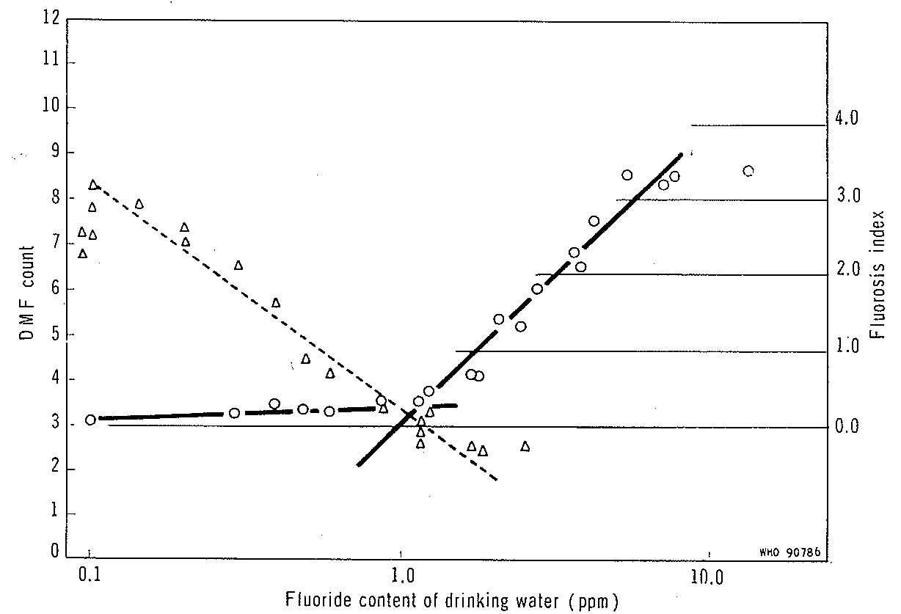
DMF (, dashed line) =Decayed, missing or filled teeth; Fluorosis Index (, solid line).
Source: WHO, (1970, p328). Note: Log scale used for the fluoride content of drinking water.

Figure 1: Relationship Between Fluoride Content of Drinking Water, Caries Experience and Dental Fluorosis Index

The ULs for fluoride intake were adopted unchanged as a Nutrient Reference Value by the Australian and New Zealand Working Group (NRV/ANZ/WG, see NHMRC & NZMoH, 2006) from the values assigned by the US:Canadian Dietary Reference Intake evaluation (FNB:IOM, 1997).
The derivation of the UL for infants and children (2-8 years old) of 0.10 mg/kg bw/day was not described in detail in the FNB:IOM (1997) or the NHMRC & NZMoH, (2006) documents. An attempt to rationalise the derivation of the ULs from the available data is described below.

Although the UL for fluoride, when expressed on a bodyweight basis, was established using data for the incidence of dental fluorosis in children it is applicable for the entire population because it will be protective of all forms of adverse fluoride effects.

Severity Scaling of Dental Fluorosis

Moderate or severe dental fluorosis is an irreversible effect caused by excessive fluoride intake during the pre-eruptive development of the teeth. Dental fluorosis is diagnosed by clinical signs and is not defined by a specific test or diagnostic indicator stain. Only moderate and severe forms of dental fluorosis are visually apparent to the naked eye. The milder forms, namely very mild and mild, do not adversely affect the function of the tooth enamel but does make the enamel more resistant to dental caries.

Moderate and severe forms of dental fluorosis are characterised by staining of all teeth with the surfaces showing marked wear, the former possibly due to increased porosity and protein content (Dean’s scale, Dean, 1942). In severe forms, increased pitting of the enamel surface can also be observed and brown staining of the teeth is more widespread. These moderate and severe forms are considered by dental professionals to be ‘aesthetically objectionable’ or a ‘cosmetic adverse effect’. On this basis, the FNB:IOM report (1997) concluded that the critical endpoint for fluoride intake was the presence of ‘moderate’ fluorosis.

FNB:IOM Upper Level for Fluoride Intake

The UL for fluoride is based on the incidence and severity of dental fluorosis in children who resided in areas with differing levels of fluoride in their drinking water supplies in the 1930s-1940s in the USA (Table 1, from Dean, 1942). Figure 1 shows that at around 1 mg/L fluoride in drinking water the incidence of caries and the incidence of adverse fluorosis were at a minimum. At about 2 mg/L fluoride the incidence of moderate fluorosis was around 1% (Table 1).

Fluoride intake was not determined by Dean (1942) but theoretical estimates were made by McClure (1943) resulting in a range of dietary fluoride intakes (including food and water) of children from communities with water fluoridation at 1 mg/L. Theoretical intakes (mid-point estimates) were 0.41 mg for 1-3 year olds, 0.55 mg for 4-6 year olds, 0.73 mg for 7- year olds and 0.92 mg for 10-12 year olds. In 1997, the FNB:IOM normalised the intake estimates from McClure (1943) to body weights and calculated a theoretical mean fluoride intake of 0.05 mg/kg bw/day (range 0.02 to 0.10 mg/kg bw/day) for early infancy to early childhood. Similar mean values were also published for children aged up to 2 years old in the 1980s (FNB:IOM, 1997). Based on the absence of moderate fluorosis with water at 1 mg/L fluoride and food, including at the upper ends of the theoretical ranges, a UL of 0.1 mg/kg bw/day was assigned.

Table 1: Fluoridation of Drinking Water and Incidence of Dental Fluorosis

 |  | Percent distribution
Fluoride  (mg/L) | N | Signs absent |  | White opaque spots |  | Brown stains and pitting
 |  | Normal | Slight/  possible | Very mild | Mild | Moderate | Severe
0 | 423 | 97.9 | 1.9 | 0.2 | 0 | 0 | 0
0.1 | 236 | 97.5 | 2.5 | 0 | 0 | 0 | 0
0.2 | 459 | 85.4 | 13.1 | 1.5 | 0 | 0 | 0
0.3 | 454 | 84.1 | 13.7 | 2.2 | 0 | 0 | 0
0.4 | 263 | 57.4 | 36.5 | 5.3 | 0.8 | 0 | 0
0.5 | 403 | 60.5 | 35.3 | 3.5 | 0.7 | 0 | 0
0.6 | 614 | 72.3 | 21.2 | 6.9 | 0.3 | 0 | 0
0.9 | 123 | 52.8 | 35.0 | 10.6 | 1.6 | 0 | 0
1.2 | 633 | 53.2 | 31.8 | 13.9 | 1.1 | 0 | 0
1.3 | 447 | 40.5 | 34.2 | 22.2 | 3.1 | 0 | 0
1.8 | 170 | 28.2 | 31.8 | 30.0 | 8.8 | 1.2 | 0
1.9 | 273 | 25.3 | 27.1 | 40.3 | 6.2 | 1.1 | 0
2.2 | 138 | 13.0 | 16.0 | 23.9 | 35.4 | 11.0 | 0.7
2.6 | 404 | 6.4 | 19.8 | 42.1 | 21.3 | 8.9 | 1.5
2.9 | 97 | 4.1 | 8.3 | 34.0 | 26.8 | 23.7 | 3.1
3.9 | 289 | 3.1 | 6.6 | 15.2 | 28.0 | 33.9 | 13.2
4.0 | 59 | 5.1 | 6.7 | 20.4 | 32.2 | 23.7 | 11.9
4.4 | 189 | 1.1 | 1.1 | 12.2 | 21.7 | 46.0 | 17.9
5.7 | 38 | 0 | 0 | 0 | 10.5 | 50.0 | 39.5
7.6 | 65 | 0 | 0 | 9.2 | 21.5 | 10.8 | 58.5
8.0 | 21 | 0 | 0 | 0 | 9.5 | 47.6 | 42.8
Adapted from Dean (1942), samples from USA States: Illinois, Indiana, Ohio, Colorado, New Mexico, Texas, South Carolina, Kansas and Iowa, age group range 9-14 years. Values in bold represent the anticipated incidence and severity of dental fluorosis that would be attributable to fluoridation at about 1 mg/L.

To support the assignment of 0.1 mg/kg bw/day as the UL, the FNB:IOM report (1997) described fluoride intake levels in children from areas with 2 mg/L fluoride as ranging between 0.08 mg/kg bw/day and 0.12 mg/kg bw/day with a mean of 0.10 mg/kg bw/day. Because fluoridation of drinking water at 2 mg/L was associated with a low incidence (about 1%) of moderate fluorosis (Dean, 1942), the FNB:IOB assumed that it was likely to be associated with intakes at the higher end of the range, namely between 0.10 and 0.12 mg/kg bw/day.

In summary, the fluoride UL for infants and children that was developed by the FNB:IOM for fluoridated water at 1 mg/L using a ‘model’ diet was adopted by the NRV/ANZ/WG (NHMRC & NZMoH, 2006) as the basis of the Australian and New Zealand UL.

Conclusion

FSANZ considers that the UL values adopted by the NRV/ANZ/WG (NHMRC & NZMoH, 2006) were based upon the best available information at the time and provided a theoretical level for fluoride intake because they were not based on actual food consumption data. The apparent discordance between the theoretical and actual intakes without an increase in the adverse clinical sign of moderate dental fluorosis suggests that the existing UL may need to be revised upward. The absence of an increase in moderate fluorosis in the community indicates that this revision is not urgent and the apparent exceedences of the UL do not indicate a safety concern.
FSANZ considers that it would be possible to develop a more robust estimate of the fluoride UL for Australia and New Zealand by incorporating dietary intakes from data collected by the NNSs in 1995 and 1997 (respectively) and in consultation with dental professionals.

References

Dean, H.T., (1942) The Investigation of Physiological Effects by the Epidemiological Method. In Moulton F.R. ed. Fluorine and Dental Health. Am. Assoc. Adv. Sci., p23-31.

Food and Nutrition Board:Institute of Medicine. (1997) Dietary Reference Intakes for Calcium, Phosphorus, Magnesium, Vitamin D and Fluoride. Washington DC, USA, National Academy press, Chapter 8, p288-313.

McClure, F.J. (1943) Ingestion of Fluoride and Dental Cries. Quantitative relations based on food and water requirements of children one to twelve years old. Am. J. Dis. Child. 66:362-369.

National Health Medical Research Council. (1991) The Effectiveness of Water Fluoridation. Australian Government Printing Service, Canberra, Australia.

National Health Medical Research Council. (2007) A Systematic Review of the Efficacy and Safety of Fluoridation. Australian Government, Canberra, Australia.

National Health Medical Research Council and New Zealand Ministry of Health. (2006) Nutrient Reference Values for Australia and New Zealand. Including Recommended Dietary Intakes. Fluoride p175-180. Commonwealth of Australia.

WHO (1970) Fluorides and Human Health. Monograph series #59, WHO, Geneva, Switzerland.

